Slackness in Our Prayers
August 7th, 2021

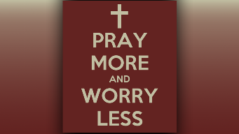
May the joy of the Lord be our strength dear Heartdwellers. Mother Mary began speaking, “I am here Clare and you are exhausted. But why?”

Father, please give us strength to go on and do Your will. Bind every lying religious spirit that tries to shut us down and open our eyes and ears to truth. Give these listeners true discernment to understand that the Holy Spirit is the author of all truth, we on the earth and those sent from Heaven are just His messengers. Amen.

I was feeling very sick and didn’t think I could go on, I heard, “The weather, humidity, intercession and opposition. You must build stamina, spiritual stamina. That is part of what laziness is all about. If you are not strengthened, you will not stand. Just keep plodding along Clare, be persistent, be an example.”

What is on your heart Mother?

“All of you. I am praying you will endure the trials that are coming upon the whole world, without hurting one another or acting foolishly. Steady as she goes. This is the key, stamina and constancy and doing your best in all circumstances. Ask Him for strength Clare, ask Him.

“There is not enough prayer going up beloved ones. There is a slackness in your prayers, because of the opposition. There needs to be a more concerted effort entering into prayers. Praying for your leaders is of the utmost importance. When they are weak, you are weak and things can happen that could have been prevented. This seeps in very subtly and you do not notice it. This is one of Satan’s tactics, to seep in slowly, imperceptibly.

“Yes, you need to sit with Him and soak in His love for you. You do not recognize it, but prayer is tiring, even for Father, it takes a great deal out of you, which must be replenished and you have not spent enough time with Him. He wants you to Clare. He has gifts for you and does appreciate your fasting. He really does. A rough start, but a good ending.

“Do not worry, just be very loving. Also, I want you to put my messages out. You will do fine, do not worry for that soul. A rough start, a good ending. Birds of a feather gather together. There is no place on earth quite like here, that is to your advantage.” And that was the end of Our Lady’s message.

God bless you dear Heartdwellers.

